Michigan and the Clean Power Plan:
Assessment of Cost-Effective Compliance Options

This summer, the U.S. Environmental Protection Agency (EPA) will finalize regulations affecting greenhouse gas emissions from existing power plants. In implementing these regulations, called the Clean Power Plan, states have broad discretion to develop the compliance and implementation strategies that best fit with each state’s unique portfolio of generation assets and opportunities.

To assist Michigan policymakers in identifying the most cost-effective methods for implementing the forthcoming Clean Power Plan regulations, the Institute for Energy Innovation (IEI) offers this whitepaper detailing the findings modeled through the State Tool for Electricity Emissions Reduction (STEER). The STEER model was developed for Advanced Energy Economy Institute by 5 Lakes Energy, a Michigan consulting firm, in partnership with researchers at the University of Michigan. The STEER model expands on a previous model developed by 5 Lakes Energy and the University of Michigan research team called the State-based Carbon Rule Analysis for Power Systems (SCRAPS). In addition to Michigan, 5 Lakes Energy is also modeling least-cost compliance strategies in Arkansas, Georgia, Illinois, North Carolina, Pennsylvania, and Virginia using the STEER model.

The STEER model was developed to help stakeholders assess different compliance options by optimizing the least-cost compliance strategy, given set parameters. All inputs may be modified by the user, allowing for the use of more granular data than the publicly available data provided in the stock model.

The STEER model demonstrates that energy efficiency represents the most cost effective compliance measure available, and maximizing both customer and network efficiency should be a central element of the state’s compliance strategy. The most cost-effective generation options involve trade offs between combined cycle natural gas, combined-heat-and-power, and renewable energy technologies. At the U.S. Energy Information Administration’s projected 2030 natural gas price of $6.73/MMBtu, the STEER model suggests that both wind and solar will displace natural gas on purely economic grounds. In addition, the long-term hedge value of fixed-price power purchase agreements using fuel-less generation technologies outweighs the difference in cost between natural gas and renewable energy – even at today’s low natural gas prices.

Notably, these strategies are fully consistent with the framework articulated earlier this year by Governor Rick Snyder in his Special Message on Ensuring Affordable, Reliable, and Environmentally Protective Energy for Michigan’s Future to guide future state energy policy, though a number of the strategies identified as lowest-cost by the STEER model may require changes to Michigan law in order to be fully realized. These modifications include eliminating artificial expenditure caps that limit utility expenditures on customer energy efficiency programs, ensuring that utility investments in reducing energy waste are at least as attractive as other investments, removing disincentives for cogeneration, and encouraging deployment of renewable energy.

- Background of the EPA Clean Power Plan

The U.S. Environmental Protection Agency (EPA) will soon release the final rule for carbon emissions from existing power plants, called the Clean Power Plan (CPP). The final rule represents the next step in the process of carbon regulation that began with the Supreme Court’s determination in 2007 that carbon dioxide (CO2) qualifies as an air pollutant subject to regulation by EPA under the Clean Air Act.

Under Section 111(d) of the Clean Air Act, EPA will set air pollutant standards for each state based on what EPA determines to be the “best system of emission reduction” (BSER). In the draft rule issued in June 2014, EPA determined the BSER based on state specific potentials for emission reductions utilizing four “building blocks” that include both traditional smokestack controls as well as “beyond the fence line” measures, namely improving the efficiency of coal plants, increasing dispatch of existing natural gas plants, deploying renewable and nuclear power generation, and reducing demand by means of energy efficiency.

Although Michigan’s emission rate target is calculated by EPA’s building blocks, there is no requirement that the state use those specific measures for compliance. Rather, in developing a compliance plan to achieve the interim (2020-2029) and final (2030-2032) targets, the state is free to use other technologies and policy tools to meet the target.

- Overview of the STEER Model

In order to give state lawmakers, regulators, and stakeholders the ability to evaluate Clean Power Plan compliance approaches with the benefit of reliable integrated resource planning data, Advanced Energy Economy Institute contracted with 5 Lakes Energy, working with researchers at the University of Michigan, to develop the State Tool for Electricity Emissions Reduction (STEER). The principal purpose of the STEER model is to facilitate stakeholder access to data and integrated resource planning analysis as states evaluate Clean Power Plan implementation options. The STEER model automatically calculates the least-cost compliance and implementation strategies, along with cost to users, given certain policy options and electricity demand and price forecasts. All data, inputs, and formulae are visible to and changeable by the user. The Michigan version of the STEER model is available for download, free of charge, at the AEE website (www.aee.net).

The STEER model builds on an earlier model, also developed by 5 Lakes Energy and researchers at the University of Michigan. The results of that previous model – State-based Carbon Rule Analysis for Power Systems (SCRAPS) – were published by 5 Lakes Energy in a February 2015 whitepaper entitled “Michigan and the Clean Power Plan: Clarifying the Compliance Options.” While many of the elements of the SCRAPS model were incorporated into STEER, the STEER model also includes a broader array of potential compliance options, allowing for greater precision in identifying those technologies and other mechanisms that are most cost-effective for compliance.

STEER is based on 2012 hourly load data for 24 representative days of the year and forecasts future loads out to 2030, considering changes in load profile that result from selected energy efficiency programs. STEER builds on the SCRAPS model to accommodate forecasted adoption of electric vehicles and demand response, storage, and smart grid programs.

Michigan STEER contains performance data for every electric generating unit in Michigan, including the multiple units in each power plant. It calculates the least-cost dispatch of these generating units to satisfy load for each hour, then calculates coal usage, natural gas usage, variable costs, carbon emissions, sulfur oxide emissions, nitrous oxide emissions, and mercury emissions based on that plan of operations.

The STEER dispatch model also derives locational marginal price for selection of least-cost carbon mitigation measures. These locational marginal prices have been verified by comparisons to historical data. If a carbon price policy is applied to dispatch, the model calculates dispatch, locational marginal price, and incremental cost of operating the power system accordingly.

To address capacity limitations, if the model finds that existing capacity is insufficient to satisfy the forecasted load, plus necessary reserve margins, it adds new natural gas combustion capacity to the generation fleet. Capacity value of combined cycle natural gas plants or renewable resources is considered when those are chosen for carbon mitigation. Costs and effects of heat rate improvements at existing plants default to the assumptions made by EPA in developing the draft Clean Power Plan. However, a STEER user is free to make plant-specific assumptions.

Notably, no additional coal plant retirements are mandated by Clean Power Plan, even if their use is radically reduced. To reflect this, the STEER model incorporates the avoided fixed cost of plant operations and the costs of replacement capacity and energy. Although not considered a cost of plant retirement, remaining book value is assumed to be securitized and accounted for in utility revenue and rate forecasts.

Renewable resource options are based on inventories of renewable resources developed by the National Renewable Energy Laboratory. Wind and solar generation are based on hourly site-specific data from NREL’s Eastern Wind Integration Transmission Study and System Advisory Model, respectively. Capacity factors, capacity credits, and hence power system value of wind and solar generation are the result of calculations using site-specific data rather than general assumptions. Hydropower resources are representative of small hydropower facilities operated run-of-river using typical Michigan streamflow. Biomass resources are grouped into eight categories running from municipal waste and landfill gas through timber residuals.

Energy efficiency measures included in the model, their costs, and their achievable potential are taken from the Michigan energy efficiency potential study performed by GDS Associates in 2013 and released as part of Governor Snyder’s “Ensuring Michigan’s Future” report series in November 2013. These measures include 190 applications used by residential, commercial, and industrial customers. For purposes of modeling effects on load profiles, we classified each measure as affecting all load or peak load. In STEER, the user can specify whether the model should consider all achievable cost-effective energy efficiency or constrain these programs to a spending cap of 2% of utility revenues, as provided in current law.

In addition to these features of Michigan’s power system, the STEER model also incorporates the operation of the Ludington Pumped Storage Plant and the possibility of power imports and exports subject to current transmission limitations established by the regional transmission organizations. A STEER user can make changes to the import and export capacity limits.

STEER models retirement of existing generating units by incorporating the capacity factors, dispatch order, air pollutant emissions, and other information that a user might consider in making retirement decisions. Cost projections based on retirements include the need to pay for remaining book value of the retired plants through securitization. Retirement decisions are not automated in the least-cost planning algorithm because those decisions are based on a variety of considerations but can be considered for cost impacts.

The STEER model considers technologies such as geothermal and nuclear electricity generation, biomass co-firing in existing coal plants, new hydropower, fuel cell cogeneration, demand response, smart grid technologies, electric vehicle integration, and battery storage.

As with any model, simplifications have been made. STEER assumes there are no binding transmission constraints within Michigan. The model might replace generation from a fossil fuel plant with, for example, renewables located in an area that lacks adequate transmission interconnections, requiring additional transmission. New natural gas and biomass plants are not assigned to specific locations, so their locations can also reflect transmission availability and support requirements. That said, model results do not appear to be distorted as a result of this simplification.

The model calculates the least-cost plan for the single year, chosen by the user, and does not aggregate year-by-year results over a period of time. For example, the model might calculate that the least-cost plan uses a new natural gas combined cycle plant based on projected conditions in 2020. However, based on projected conditions in 2030, the model may calculate that a combination of wind generation and cogeneration is more cost-effective. The model does not attempt to resolve these differences by solving the dynamic programming problem of how best to act over the full life-cycle of each generator although that analysis can be performed by using the model to analyze results year-by-year and evaluating the life-cycle results. As such, the results of the model from any given year should be viewed in the context of long-term utility and regulatory planning, including underlying changes in the cost of fossil fuels used for generation and the desirability of hedging against volatility in fossil fuel prices.

With these simplifications in mind, STEER represents a useful Clean Power Plan strategic planning tool for regulators and stakeholders alike, enabling consideration of a wide range of alternatives and providing transparency as to the model’s calculations in a particular scenario. STEER users may rely on the existing publicly available data that is included in the model or the data can be replaced with more granular information if desired. Stakeholders can use this tool for analysis and comparison with analyses produced by utility companies and other stakeholders.

- Key Findings

The data developed by running various scenarios through the STEER model leads to a number of key findings:

- The STEER model suggests that reducing energy waste is Michigan’s least-cost tool for complying with the Clean Power Plan. Customer-focused energy efficiency upgrades and network efficiency measures such as conservation voltage reduction (CVR) and dynamic Volt/VAR optimization – are cost-effective and can be justified on purely economic grounds regardless of the Clean Power Plan. These measures, combined with a modest increase in distributed generation, can account 35% of the total greenhouse gas emission reductions likely to be required.

- Least-cost generation options represent a tradeoff between natural gas, cogeneration, and renewable energy, depending on the long-term projected cost of natural gas. If natural gas prices approach the Energy Information Administration’s 2030 projection of $6.73/MMBtu, wind and solar displace natural gas on purely economic grounds. Indeed, even relatively modest increases in the 30-year cost of natural gas can dramatically change the economics of power generation. In addition, a strategy that simply shifts from coal to gas would be imprudent based on the underlying volatility in fossil fuel prices. Instead, the long-term hedge value of fixed-price power purchase agreements using fuel-less generation technologies outweighs the difference in cost between natural gas and renewable energy – even at today’s low natural gas prices.

- The STEER model confirms the priorities contained in Governor Rick Snyder’s March 2015 energy message to the Legislature – including reducing energy waste and evaluating generation options on long-term cost. To be fully realized, these options need supportive public policies and regulations, including reducing disincentives to utility investments to customer energy efficiency and network optimization, as well as reducing barriers to industrial cogeneration.

- Recommendations for Cost-Effective Compliance Options for Michigan under EPA’s Clean Power Plan

The STEER model develops least-cost compliance recommendations based on comparative evaluation of available generation, efficiency, storage, and grid management options. On this basis, the STEER model builds on the SCRAPS model, which identified a pathway utilizing customer energy efficiency and a generation mix that moves from coal to a combination of natural gas and renewable energy. In addition, the STEER model suggests that expanding network and grid efficiency efforts, including dynamic Volt/VAR optimization and conservation voltage reduction, should also be incorporated into Michigan’s compliance strategy, and that industrial cogeneration can play an important role in reducing carbon emissions in a cost-competitive manner, displacing some new combined cycle natural gas generation.

Energy efficiency improvements in homes and businesses

A starting point for any cost-effective compliance strategy needs to be expanding energy efficiency in Michigan homes and businesses. This strategy, which Governor Snyder has described as “eliminating waste,” should be a central part of utility planning even absent the requirements of the Clean Power Plan as energy efficiency improvements save ratepayers money.

In evaluating the potential for energy efficiency savings in Michigan, the STEER model incorporates the findings of the study performed by GDS Associates in 2013 and released as part of Governor Snyder’s “Ensuring Michigan’s Future” reports. The GDS study evaluated three possible energy efficiency scenarios:

- Economic potential, which includes all cost-effective energy efficiency measures. The GDS report concluded that utilities could cost-effectively achieve savings of 31% to 35% of total projected electric load through 2023.
- Achievable potential, which accounts for administrative costs, the need to ramp up programs over time, and other “real world” challenges to program implementation. The report concluded that Michigan’s total achievable energy efficiency potential for electricity is 14.5% to 16.1% by 2023.
- Constrained potential, which overlays current statutory limitations involving cost caps on utility energy efficiency expenditures.

As the following chart shows, running these different scenarios through the STEER model confirms that energy efficiency is highly cost-effective.
GDS Achievable Potential
GDS Economic Potential
GDS Constrained Potential

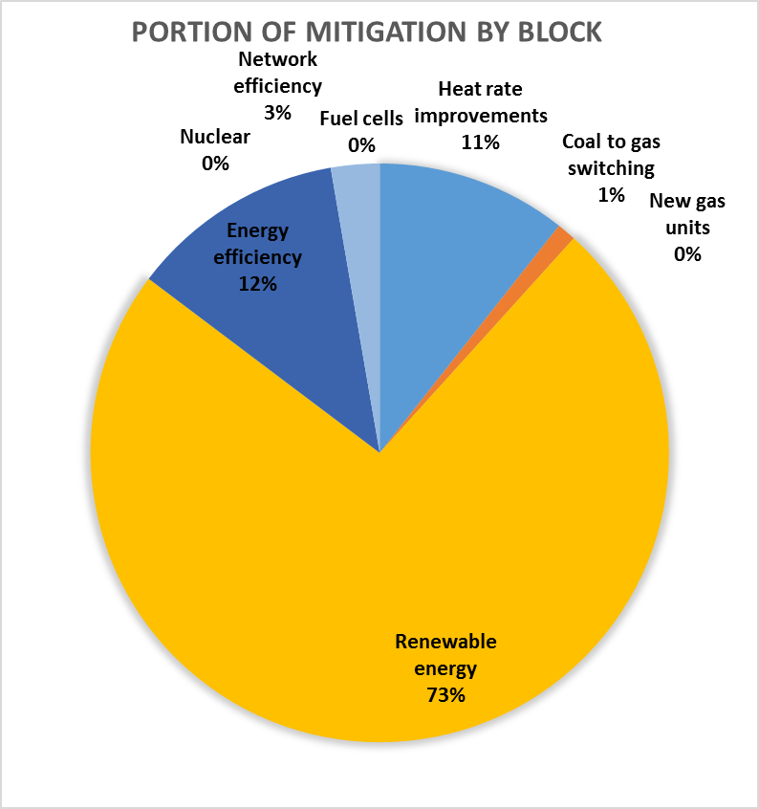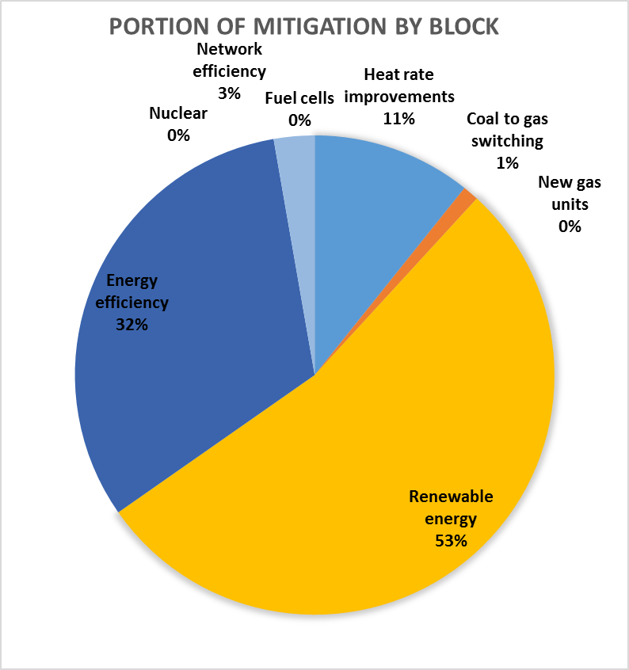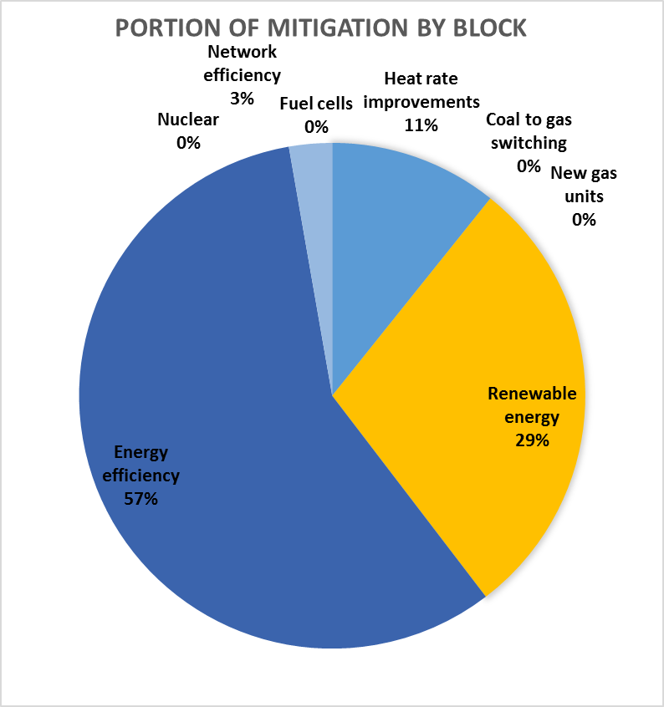
Utility Cost of EE: $596 mil.
Net cost of CPP: ($811 mil.)
Average Rate Change: ($0.0085/kWh)
Load reduction: 20%
Utility Cost of EE: $366 mil.
Net cost of CPP: ($96 mil.)
Average Rate Change: ($0.0009/kWh)
Load reduction: 11%
Utility Cost of EE: $132 mil.
Net cost of CPP: $673 mil.
Average Rate Change: $0.0059/kWh
Load reduction: 4.2%
The model shows that Michigan could reduce overall load 20% by implementing all cost-effective energy efficiency opportunities, at a total projected savings of $811 million to Michigan ratepayers, or a $0.0085/kWh reduction in rates when compared to the base case. Simply implementing the achievable energy efficiency potential would reduce load by 11% and generate $96 million in net savings – a savings of $0.0009/kWh. Maintaining the current statutory limitations on expenditures for energy efficiency would negate these projected savings while reducing the total impact of load reductions and requiring additional new and more costly generation to make up the difference.

Network and grid efficiency options

Network efficiency technologies include various measures in the distribution grid, with the largest effects from dynamic Volt/VAR optimization and conservation voltage reduction. VAR stands for Volt-Amp Reactive, also called Reactive Power or Power Factor. Dynamic Volt-VAR optimization uses sensors in the distribution network, such as smart meters, together with voltage line regulators, capacitor banks, and similar devices to increase the percentage of power generated that ultimately reaches the end user.

Conservation voltage reduction involves reducing voltage below nominal voltage levels, which reduces end-use power consumption by about 0.75% per 1% voltage reduction. CVR can be applied modestly without dynamic Volt/VAR optimization, though the two applications work better when combined. Combined they can reduce power consumption by 3% to 5%. The STEER model assumes 2% for distribution customers only.

As the following graphics demonstrate, network efficiency has the potential to save approximately $110 million in Clean Power Plan compliance costs:
With Network Efficiency
Without Network Efficiency
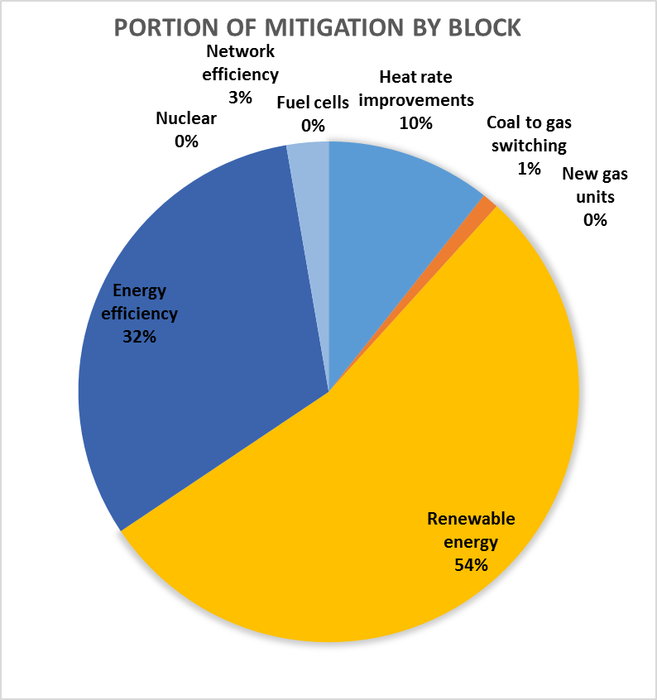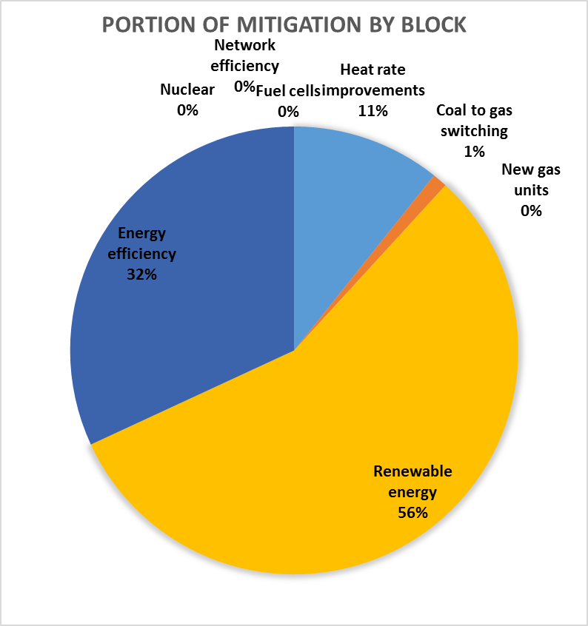
Net cost of CPP: $14 million
Average Rate Change: $0.0001/kWh
Load reduction: 0%
Net cost of CPP: ($96 million)
Average Rate Change: ($0.0009/kWh)
Load reduction: 3.0%

Network efficiency is the most cost-effective carbon mitigation measure in the model under all scenarios, and should be pursued even in the absence of the Clean Power Plan requirements. Under the reference case assumptions, carbon is mitigated at a cost of $133.24/ton CO₂. Least-cost carbon mitigation plans and costs in the scenarios summarized below are for 2030 based on EIA Reference Scenario fuel prices in 2030 without plant retirements beyond those already announced.

Generation tradeoffs

While energy efficiency can satisfy a significant portion of Michigan’s carbon reduction requirements, additional generation is necessary for any Clean Power Plan compliance strategy. If we assume the achievable energy efficiency potential modeled by GPS, 2% network efficiency, and 1% from modifications to Michigan’s net metering cap, these account for about 35% of Michigan’s required carbon mitigation under the draft Clean Power Plan rule. Changes in generation, therefore, must accomplish the remaining 65% of carbon mitigation.

In running a range of possible generation options, the STEER model found that the least-cost generation options are a mix of natural gas and renewable energy, the balance between them depending on forecasts of the long-term price of natural gas.

The U.S. Energy Information Administration projects natural gas prices at $6.73/ MMBtu in 2030, far above the cost at which renewable energy outcompetes natural gas on a cost basis. The following chart highlights generation trade-offs as various natural gas prices.

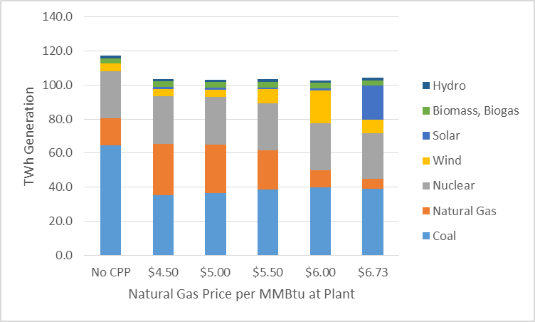

Indeed, natural gas is the preferred generation option only if the long-term price remains below $4.50/MMBtu. When long-term natural gas price exceed $4.90/MMBtu, replacing some combined cycle natural gas generation with industrial cogeneration becomes economically preferable, and wind becomes the preferred generation source when natural gas price projections exceed $5.75/MMBtu. Finally, solar for daytime generation becomes cheaper than using natural gas when natural gas prices top $6.40/MMBtu, which then triggers a major restructuring of generation mix. By way of comparison, over the last 20 years, the price of natural gas prices has fluctuated greatly, from a low of $1.79/MMBtu in February 1997 to a high of $13.42/MMBtu in October 2005.

The STEER model also assesses the economic competitiveness of renewable energy and other carbon-less generation sources in addition to wind and solar. New nuclear, new hydropower, natural gas fuel cells, and offshore wind are not cost-effective in any of the modeled scenarios. For biomass, based on current costs, the order of selection of biomass resources would be landfill gas, urban wood, primary mill, secondary mill, and municipal solid waste, then – with a big gap in cost per unit of carbon mitigation – for forest residues, switchgrass on CPR lands, and crop residues. Of these, only landfill gas is competitive statewide.

Importantly, when evaluating the prudency of natural gas generation, it is important not just to look at the current cost of natural gas, but the uncertainty associated with long-term natural gas prices. While hedging instruments are routinely used to guard against such volatility in the near- and medium-term, one primary advantage of fuel-less technologies is the ability to provide fixed-price power purchase agreements over the long-term.

Markets recognize the importance of these 25-year hedges, which are valued at approximately $2.71/MMBtu – or more than 60% of the price of gas at $4.50/MMBtu or less. While it is not the price in any one year that matters, the fact that long-term natural gas prices are projected to increase substantially and the uncertainty associated with any long-term prices dependent on underlying fossil fuel costs argue against overreliance on natural gas for electricity generation. A balanced portfolio that includes substantial amounts of renewable energy and industrial cogeneration provides the dual benefits of long-term price stability and the maintenance of affordable energy for Michigan ratepayers in all classes.

- Policy Implications of Recommendations

As the STEER model demonstrates, Michigan has multiple options on which to base its compliance plans under the EPA’s Clean Power Plan. Despite the advantages these compliance tools, however, a number of policy measures currently frustrate or block the adoption of some compliance measures. In order to fully achieve the potential for cost-effective implementation of the Clean Power Plan, a number of statutory and regulatory changes are needed. These include:

- Eliminating the expenditure cap for energy efficiency improvements
- Making cost-effective efficiency investments as attractive to utilities and their shareholders as new generation investments
- Authorizing MPSC to require cost-effective energy efficiency measures – both network efficiency and customer efficiency measures – as part of any future integrated resource planning or certificate of necessity proceedings
- Removing barriers to deployment of combined-heat-and-power systems, including excessive stand-by charges, interconnection roadblocks, and other disincentives for cogeneration
- Ensuring meaningful growth in renewable energy, either through continuance of the current renewable portfolio standard or through incorporation of risk considerations and 25-year hedge values of fuel-free technologies as part of MPSC review of utility plans

Notably, many – if not all – of these findings are consistent with the Governor’s recommendations contained in his March 2015 energy message to the Legislature, making the implementation of a cost-effective Clean Power Plan implementation strategy a centerpiece of any effort to develop a “no regrets” energy policy for Michigan.

- Conclusion

With the EPA set to release its final rule implementing the Clean Power Plan under Section 111d of the Clean Air Act, Michigan has a number of options for compliance. A thoughtful implementation plan not only has the potential to dramatically reduce carbon dioxide emissions from Michigan’s power sector but to identify the most effective opportunities for complying with these new federal rules.

The identification of lowest-cost combination Clean Power Plan compliance options through the STEER model should be central to these considerations. Some of the recommendations should be pursued on purely economic grounds, as they have the potential to deliver measurable cost savings even absent federal climate regulations. Others – such as optimizing new generation sources including natural gas, industrial cogeneration, and renewable energy – represent the least-cost options available to regulators, utility planners, and policymakers to comply with the Clean Power Plan.

About the Institute for Energy Innovation

The Institute for Energy Innovation is a Michigan non-profit corporation registered under Section 501c3 of the Internal Revenue Code. IEI’s mission is to promote greater public understanding of advanced energy and its economic potential for Michigan, and to inform the public and policy discussion on Michigan’s energy challenges and opportunities. IEI’s activities are focused on policy development and research; community-based energy programs; and industry engagement activities. IEI is a state partner organization of Advanced Energy Economy.

About Advanced Energy Economy Institute

Advanced Energy Economy Institute (AEE Institute) is a 501(c)(3) charitable organization whose mission is to raise awareness of the public benefits and opportunities of advanced energy. AEE Institute provides critical data to drive the policy discussion on key issues through commissioned research and reports, data aggregation, and analytic tools. AEE Institute also provides a forum where leaders can address energy challenges and opportunities facing the United States. AEE Institute is affiliated with Advanced Energy Economy (AEE), a 501(c)(6) business association, whose purpose is to advance and promote the common business interests of its members and the advanced energy industry as a whole.

About 5 Lakes Energy

The 5 Lakes Energy team provides the expertise and experience to move
clean energy and sustainability aspirations into concrete action. The principals
and consultants of 5 Lakes Energy catalyze collaborations and aggregate
resources, building consensus and support to operationalize clean energy
ideas and ambitions. Working with the private sector, foundations and nonprofits,
government and academia, 5 Lakes Energy offers a portfolio of
services that enable and accelerate innovation.

Acknowledgements

Funding for the STEER model was provided by Advanced Energy Economy Institute.

Funding for the SCRAPS model on which the STEER model builds was provided by The Energy Foundation.

Primary development of the STEER model was initiated by 5 Lakes Energy and overseen by Douglas Jester. Additional development was done in partnership with The University of Michigan under the direction of Principal Investigator Dr. Jeremiah Johnson under contract with 5 Lakes Energy. University of Michigan graduate student Rachel Chalat did much of the model development under Dr. Johnson’s direction. IEI, AEE Institute, and 5 Lakes Energy are grateful for their excellent work.

Douglas Jester of 5 Lakes Energy was primarily responsible for development of the model and for running the various modeling scenarios on which this whitepaper is based.

Dan Scripps of IEI served as the lead author of this whitepaper, with additional input from Douglas Jester of 5 Lakes Energy and Maria Robinson and Matt Stanberry of AEE.

IEI also wishes to thank Liz Boyd of Liz Boyd Public Relations and Monique Hanis and Robert Keough of AEE for their assistance in offering input on the substance of the whitepaper and their work in communicating the key themes identified.

